**DETAILED PROJECT REPORT ON JAL PAKHWADA**

**VILLAGE :Chuchuyimpang village**

**BLOCK: Ongpangkong North**

**DISTRICT: Mokokchung**

**STATE: Nagaland**

**LATITUDE: 26.33°N**

**LONGITUDE: 94.50°E**

**SCHOOL : Hill View Higher Secondary School Mokokchung , Nagaland**

VILLAGE DETAILS

According to Census 2011 information the location code or village code of Chuchuyimpang village is 267196. Chuchuyimpang village is located in Ongpangkong circle of Mokokchung district in Nagaland, India. It is situated 5km away from sub-district headquarter Ongpangkong (tehsildar office) and 5km away from district headquarter Mokokchung.

Chuchuyimpang has a total population of 3,774 peoples, out of which male population is 1,878 while female population is 1,896. Literacy rate of chuchuyimpang village is 86.09% out of which 86.69% males and 85.50% females are literate. There are about 853 houses in chuchuyimpang village. Pincode of chuchuyimpang village locality is 798601.

Mokokchung is the nearest town to chuchuyimpang for all major economic activities, which is approximately 5km away.

Chuchuyimpang is administered by the Village Council which is the elected representative of the villagers. There are a WATSAN Committee with members consisting of women.

**OBSERVATION AND FINDINGS DURING DISCUSSION AND TRANSECT WALK:**

➢Theschools in chuchuyimpang have rainwater harvesting structure or tap connections.

➢In Health and Wellness centre. It has a tap connection and rainwater harvesting structure.

➢ Gram Panchayat Building has separate toilets for both genders and also have tap connection.

➢ They are testing the water quality by making use ofFTK. There are ten (10) traditional wells in the village.

➢ It has been found that Chuchuyimpang village has a good provision of water sources and has been supplying to every household. Newly tap water connection has been set up in every sectors (Khel) under JJM.

SUGGESTIONS

➢ The Village Council is very complacent with the sufficient supply of water all throughout the year and is ignorant about the waste and grey water generated by the households which is transported from the village build up areas. They are not aware that the runoff which carries all the waste generated from the village build up area will have a negative impact on the downstream and their neighbouring villages. Therefore the team made the participants aware on the ill effects on the environment.

➢ The 4 traditional wells were totally neglected since they have enough water supplies drained from the source. Therefore the participants were advised to renovate and protect the traditional well which, once upon a time was the only source and had sustained the village for many decades. The wells will also be necessary in times of emergencies like damage of the main source or in case of fire.

**PHOTO GALLERY**

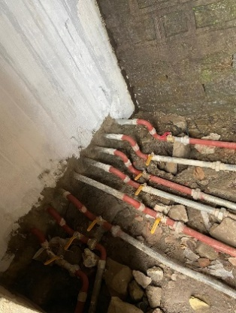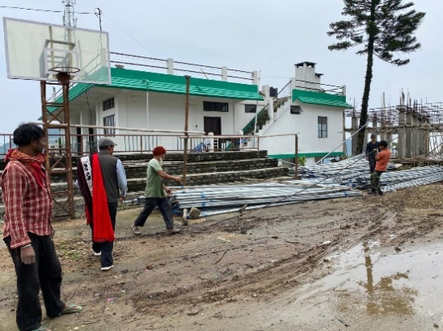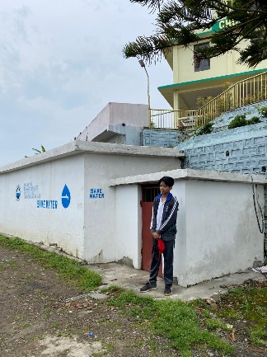

**50,OOO liter water tank Pipe connections to GI pipes**

**Different Khels (sector)**

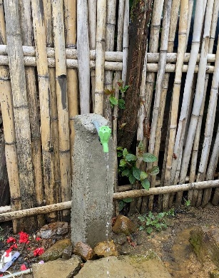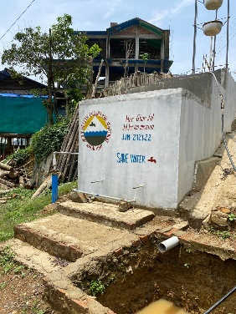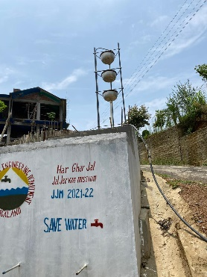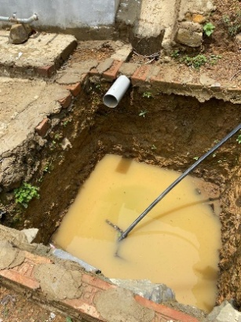

**Water purifier (Soak pits) Water filteration Tap connection**

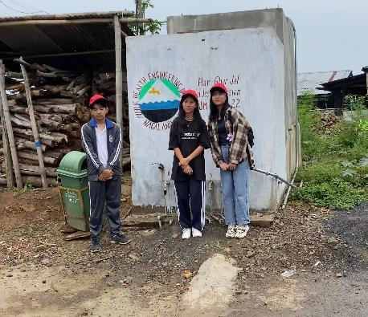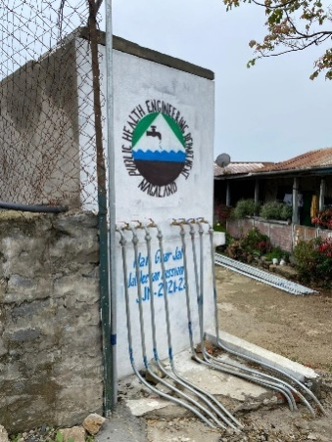

**Water tank Pipe connection**

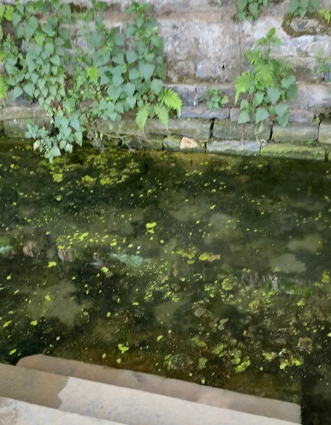

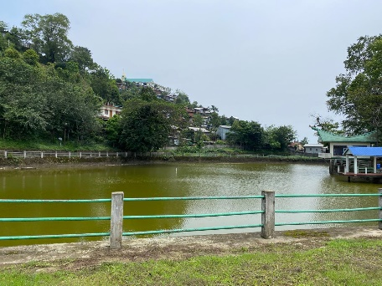

**Natural well Natural pond**

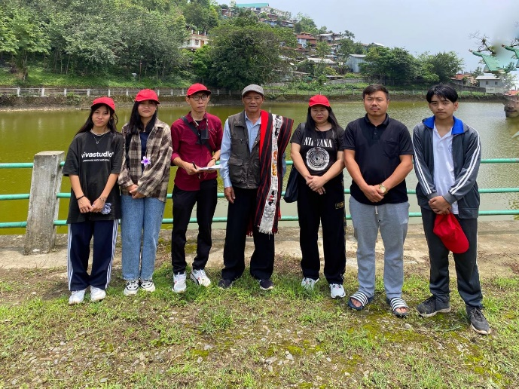

**Jal Pakhwada team (Hill view higher secondary school)**

**With Watsan Chairman and council members**